Case study -1

1. How to get part-worth and standardized part-worth?

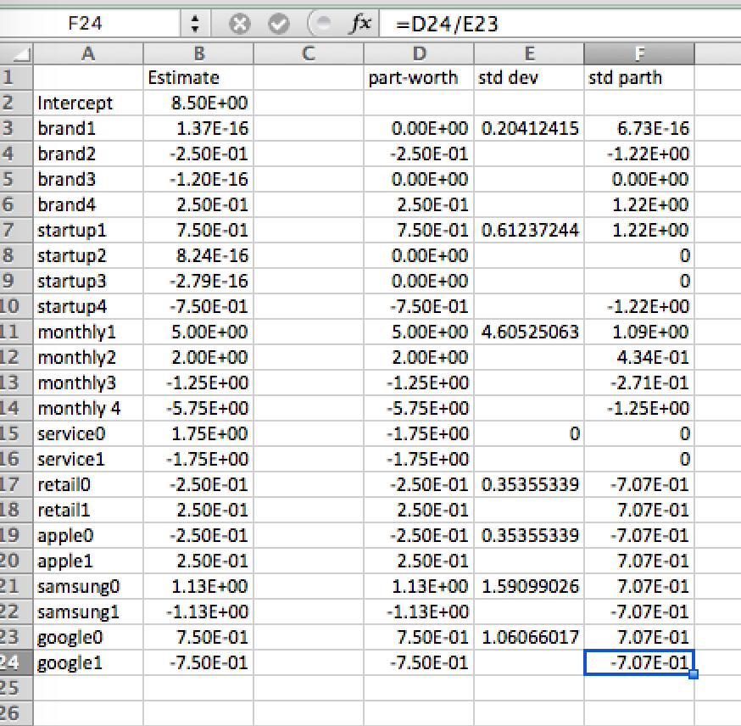

1. Why we use standardized part-worth in the spine chart?

We use standardized part-worth to compare between the variables. It makes comparison easy.

1. How to calculate attribute importance?

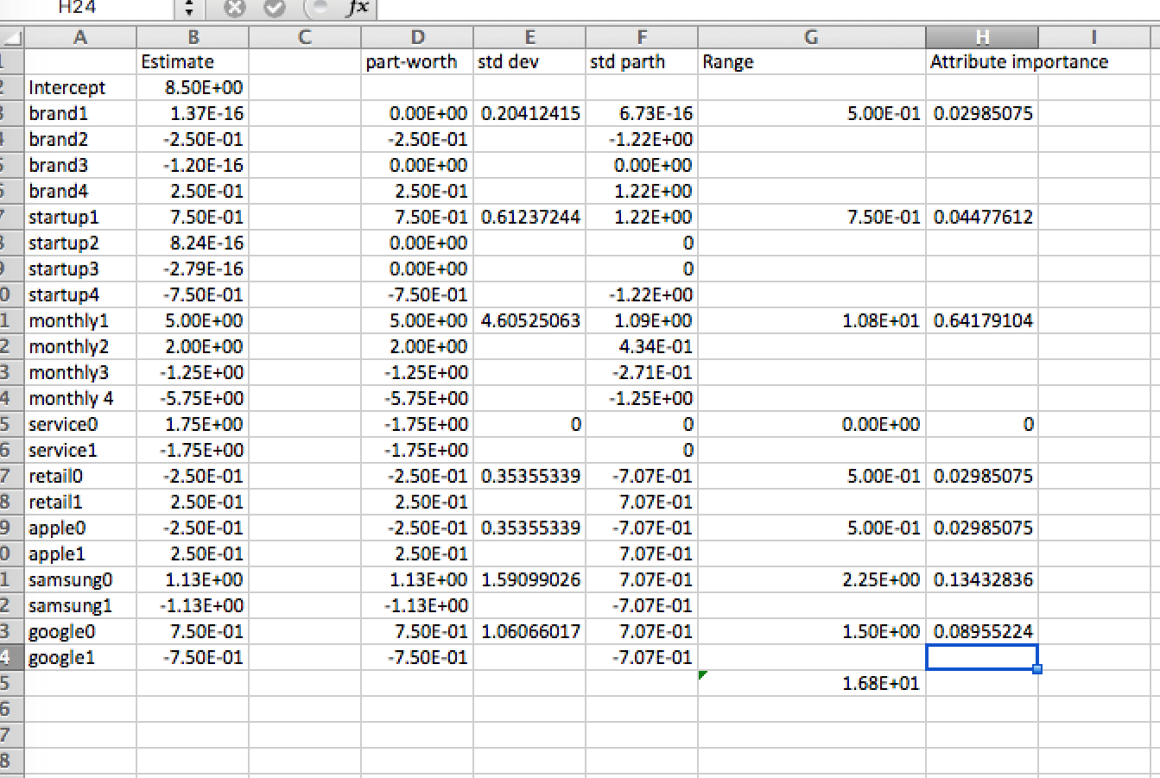

1. What is the limitation of this study?

R square value suggests overfitting, degree of freedom is 1 and data is small